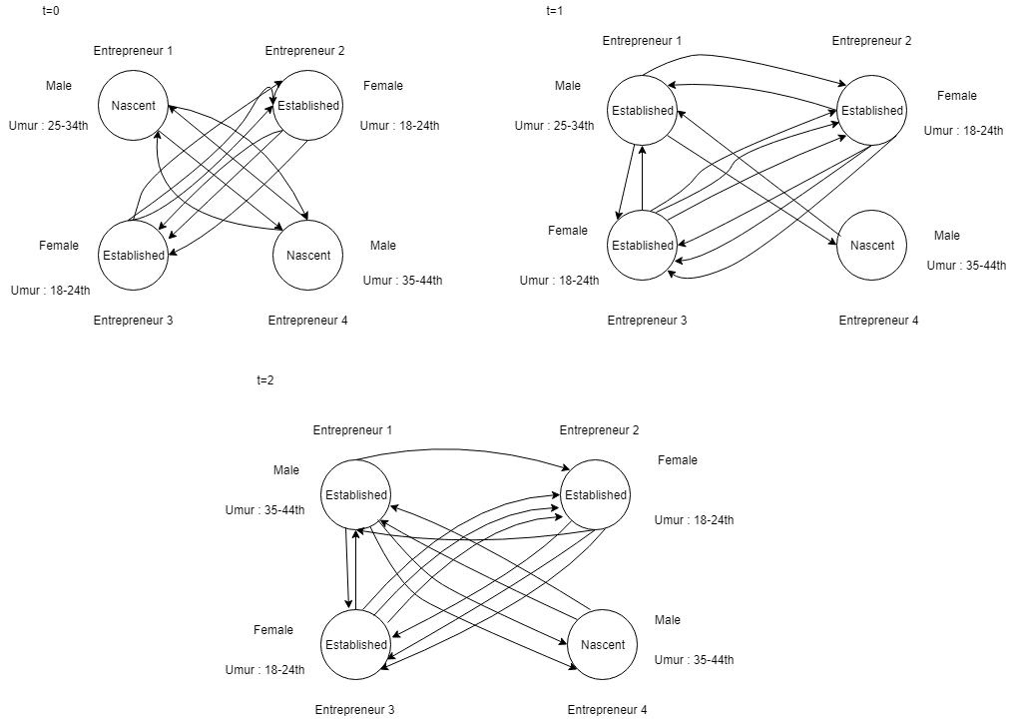

E : Entrepreneur 1, Entrepreneur 2, Entrepreneur 3, Entrepreneur 4.

Alpha : Gender, Kelompok wirausaha dan umur.

N (t=0) : Bidang usaha entrepreneur 1 sama dengan Entrepreneur 4, bidang usaha entrepreneur 2 sama dengan Entrepreneur 3, gender dan umur entrepreneur 2 sama dengan entrepreneur 4, gender entrepreneur 1 sama dengan entrepreneur 4.

Bobot (t=0) :

|  |  |  |  |  |
| --- | --- | --- | --- | --- |
|  | Entrepreneur 1 | Entrepreneur 2 | Entrepreneur 3 | Entrepreneur 4 |
| Entrepreneur 1 | 0 | 0 | 0 | 1 |
| Entrepreneur 2 | 0 | 0 | 1 | 0 |
| Entrepreneur 3 | 0 | 1 | 0 | 0 |
| Entrepreneur 4 | 1 | 0 | 0 | 0 |

Rho : Pertumbuhan ekonomi

Sigma : perubahan kelompok wirausaha (entrepreneur 1) menjadi established, perubahan umur entrepreneur 1 (25-34th) menjadi 35-44th.